CAQ Application Final Report

Prepared by Team Zhao

Introduction

Purpose of the Project

Scope of the project

Requirements

Overview

Database Relationship Requirement Specification

Relationship between Schools, Deans, Chairs and Departments

New Program Information Relationship

Program Outcome Relationship

Software Design and Implementation

Software model and tools

Database Design

UI Design

Source Code

Testing Plan

Training Plan

User Manual

Specification of Web Application

User Access Level

Video Demo

Using Web Application

Folder Structure

Home Page

Add Data Form

Add Dean Information Example:

Add Program Information Example:

Create Folder Form

Change Program Status Form

Approve or Disapprove a Pending Program

Program Approval Upload Form

Logout(About Us for now)

File Download

Final Client Acceptance Sign-off

Summary

Team Information

# Introduction

## Purpose of the Project

The purpose of this project is to aid Centre for Academic Quality (CAQ) with sharing program specific information within the sub departments. Furthermore, this project is designed to eliminate the heavy paperwork and ease the process of sharing documents with the help of automated web application. Moreover, upload and download large size files was the most important feature to our client. These large files could be format of word, excel and pdf. They require a web application to facilitate both on- and off-campus access. To generalize the purpose of this project is to provide an automated system which will eliminate the paperwork that is very prone to error.

## Scope of the project

Our Team has have been asked to establish the plans to be used during the development of the single Centralized Database for the (CAQ).This project will develop and deliver a new web application. The web application will be tailored to client’s specific needs such as developing web forms for specific file information storage. The web application will stay consistent with the department’s image, quality. This web application will have a major part dedicated to the database a centralized database to store the web form information safely and reliably. Database is tweaked to be contain relationships, maintain data integrity and consistency. The project is planned to be completed onDecember 17, 2015.

# Requirements

## Overview

The Centre for Academic Quality (CAQ) oversees a number of different areas related to Centennial’s programs of instruction. CAQ is currently split into a number of different areas: new program development, articulations/accreditations and comprehensive program quality review. CAQ is looking for a way to integrate this information into a single database to facilitate the flow of information between CAQ’s various areas. Currently, all information is stored via multiple Excel files on a shared drive but CAQ would like to have a relational database created with friendly user interface (i.e. forms) where could store program-specific information.

The database would have to be accessible both on- and off-campus. The user would like to be able to generate reports and potentially set/send alerts to users to notify of due dates. It would also require that we can upload files (file sizes may be large). A feature to upload information from a standardized Word template and Excel spreadsheet would be ideal[1] . The designated site administrator within CAQ should be able to maintain the site with features such as adding/removing users, adding or editing forms/tables, etc. The database would have to be compatible with other College IT systems so that we could integrate where necessary.

|  |
| --- |
| **Tasks to be implemented within the project** |
| Code the login algorithm |
| Merge report feature within the project |
| Hide the files within “File Download” based on the user access level/rights |
| Add the column “File Uploaded By” within the “File Download” section |
| Transfer information from uploaded file to the web form |
| Provide a feature to edit the information added through forms such asPAC and CPQR form |
| Allow a preview of files before downloading |
| Develop feature to view the “Recent Activity” of other users |
| Create new web forms if needed by client |
| Host the Web Application |

## Database Relationship Requirement Specification

### Relationship between Schools, Deans, Chairs and Departments

Programs

Departments

School

Dean

Department 1, Chair 1

Program Coordinator 1

Program Coordinator 2, etc.

Department 2, Chair 2

Program Coordinator 1

Program Coordinator 1, etc.

### New Program Information Relationship

New Program Idea

Certificate, diploma, advanced diploma, graduate certificate program proposal created

CVS Proposal Approved

MTCU Funding Approved

Move Forward with Internal Program Information

Degree proposal created

PEQAB Approved

Move forward with Internal Program Information

### Program Outcome Relationship

Certificate, diploma, advanced diploma, graduate certificate

Program Outcomes from CVS

Approved Title Change Request Form

New Program Standard File (New CAAT Standards Notification)

Voluntary update by program

Degree

PEQAB Report

PEQAB Renewal Report

# Software Design and Implementation

## Software model and tools

In Agile model we have advantage that customer’s satisfaction and requirements meet rapidly, continuous delivered of web forms. Our clients, developers and testers constantly interact with each other to meet the deliverables. Since we used agile methodology there were many back-forth changes in database, designs and back-end coding to meet its specifications. The tools which we used are ASP.NET/C# framework to create the presentation and business logic layers of the website. We also used the Test Driven Development (TDD) approach, which ensures high quality of the work and less prone to errors. Furthermore, the database was created using the SQL Server Management Studio 2012 environment and the website was developed using the Visual Studio 2013 IDE.

The Methods, Tools, and Techniqueswhich we used for this project are:

1. Git and GitHub for version control

2. Visual Studio “Testing environment”

3. Agile methodologies

4. Github for version control

## Database Design

The design of the data has been done with consideration of the data integrity. The data is designed with primary key and foreign key to establish relations between two tables and to ensure data consistency. Furthermore, constraints on the data field has been established to allow specific value to keep a standardized and consistent data flow. Below is the database relationship display as model in visual studio.

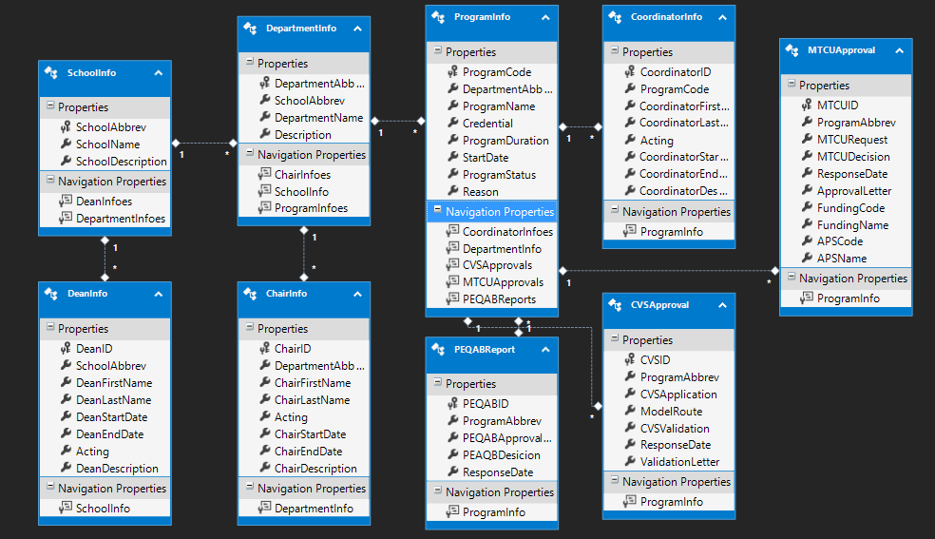

## UI Design

Using Bootstrap as HTML, CSS and JS framework for developing the project. Below is the UI design for master page.

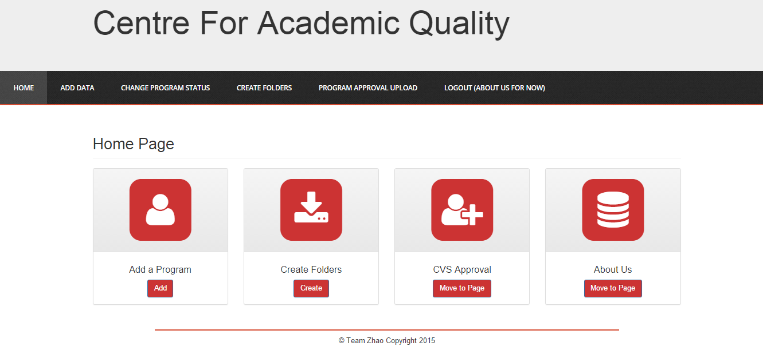

## Source Code

Refer to the code files [ProgramInformationApplication] in Project in ZIP.zip.

## Testing Plan

Items Tested

· Verify each page displays correctly according to the document.

Verify the valid and require field are input correctly before user submit the changes.

· Verify each action form bean supports all the values in JSP pages and comply with design model.

· Verify all the action classes correctly implement the design model.

· Verify all the persistent object facades correctly implements the design model

· Verify the persistent service correctly implements the design model

## Training Plan

* How to create new folders
* How to upload files
* How to download files
* How to update information on different available forms

# User Manual

## Specification of Web Application

It is very important to know your system, to use it to its full potential. We had implemented the application using the best practices and current industry standards. The prerequisites for our software in the user manual

* **Operating System**: Windows 20
* **Framework**: .NET 4.5
* **Language Compiler**: ASP.NET and C#
* **Database**: SQL Server 2014

## User Access Level

We don’t have a logout login system for now and this project will be continued work on for next semester by other group hopefully. If we added authentication, it will be hard for the next group continue developing and testing.

## Video Demo

Please refer to the Release2.wmv video

## Using Web Application

### Folder Structure

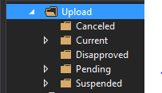

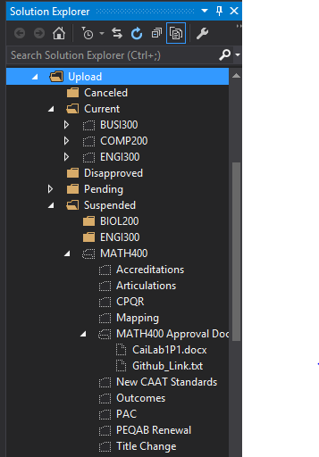

### Home Page

When you hover on the tab you will see different types of forms that you can use in your day-to-day use of this application. As shown in the picture below. Using this forms, you can store vital information into the database and use it later while generating reports. You may also upload the files while submitting the forms. This files are shared and viewed under “File Download” tab, which will be introduced to you soon.



### Add Data Form

When you hover on ‘Add Data’ tab you will see different type of inserting data, you could add chair information, coordinator, dean, department, school, program information into database accordingly.

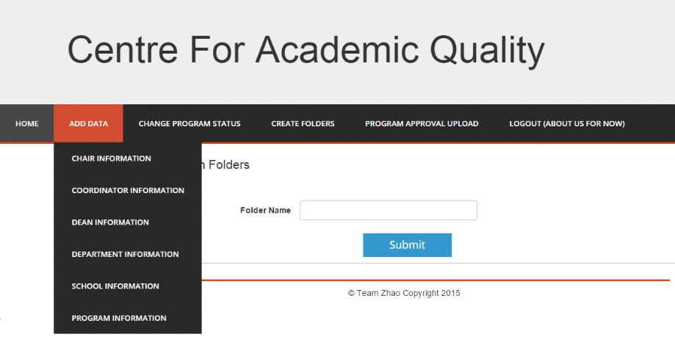

#### Add Dean Information Example:

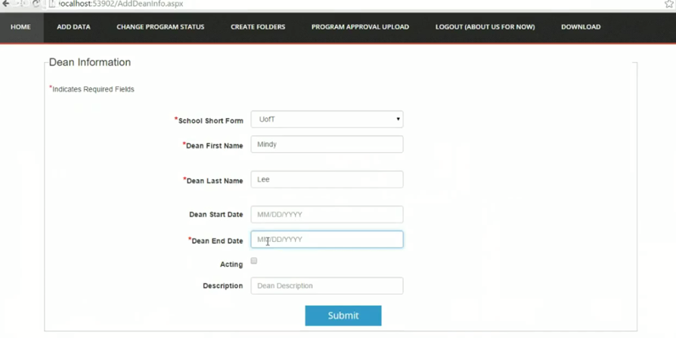

#### Add Program Information Example:

when you click submit for add a program information, a new program folder will be created with correspond subfolder as well as data will be inserted into database.

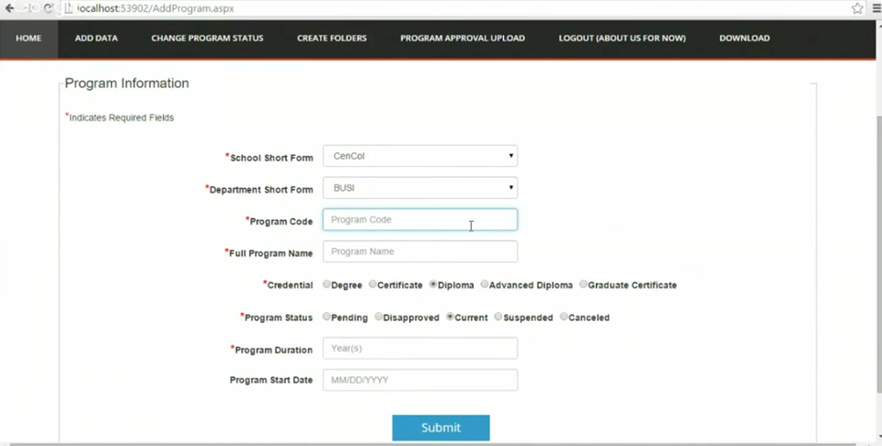

### Create Folder Form

When you create folder in this form and click submit, one program folder will be generated into database as well as the correspond subfolders for the new program folder.

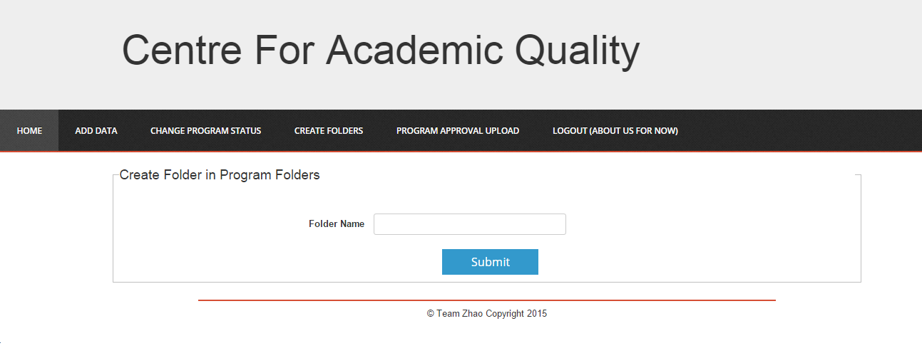

The Correspond subfolder for every current program folder:

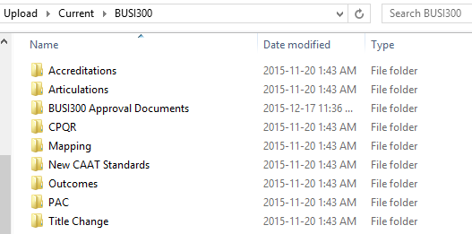

### Change Program Status Form

When you hover on change program status form, you could choose to “approve or disapprove”, “suspend or cancel” and “unsuspend or cancel” to change program status. The program folder will move to correspond subfolder.

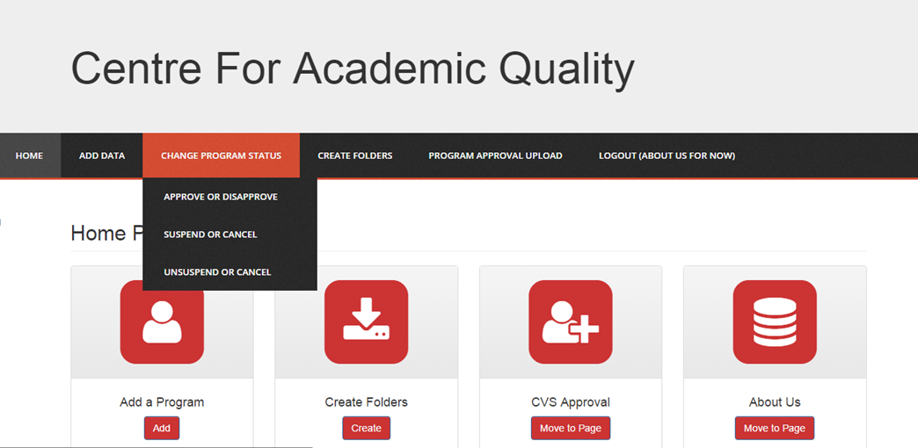

#### Approve or Disapprove a Pending Program

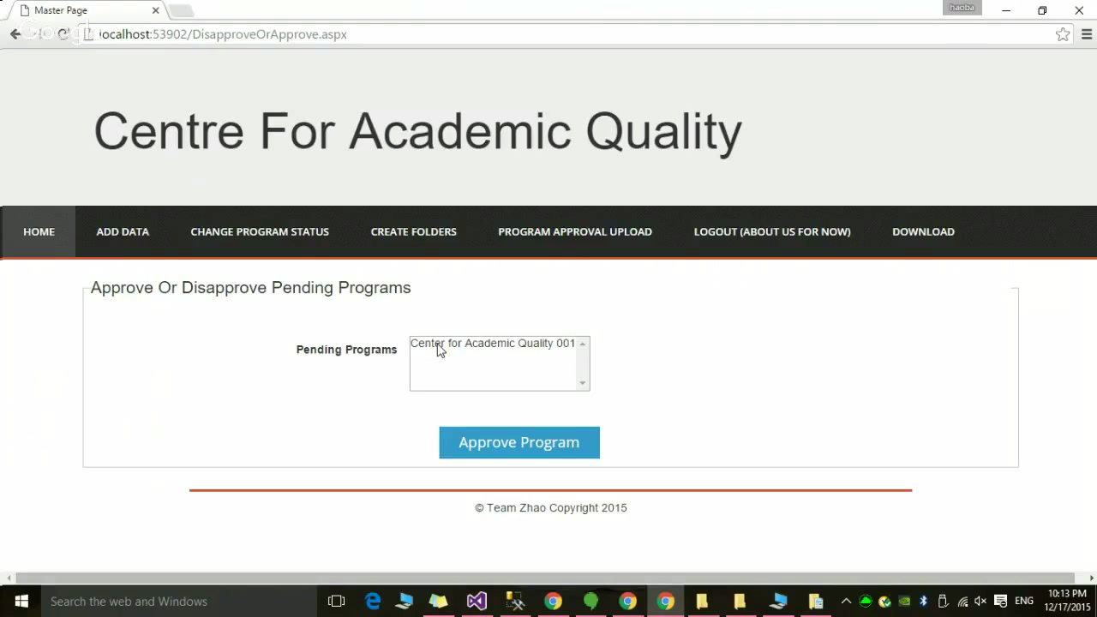

### Program Approval Upload Form

When you hover on Program Approval Upload Tab, you could upload file to specific program by choosing school, department. The file will be uploaded to related program folder and change the data in database accordingly.

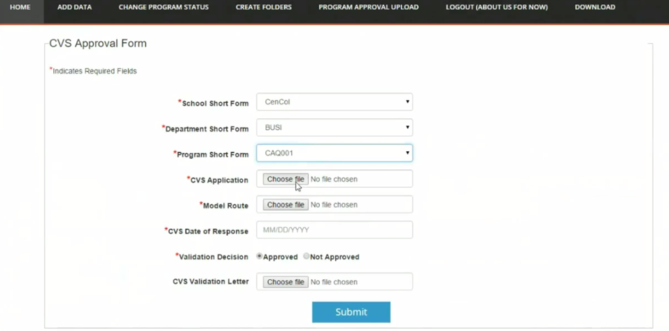

### Logout(About Us for now)

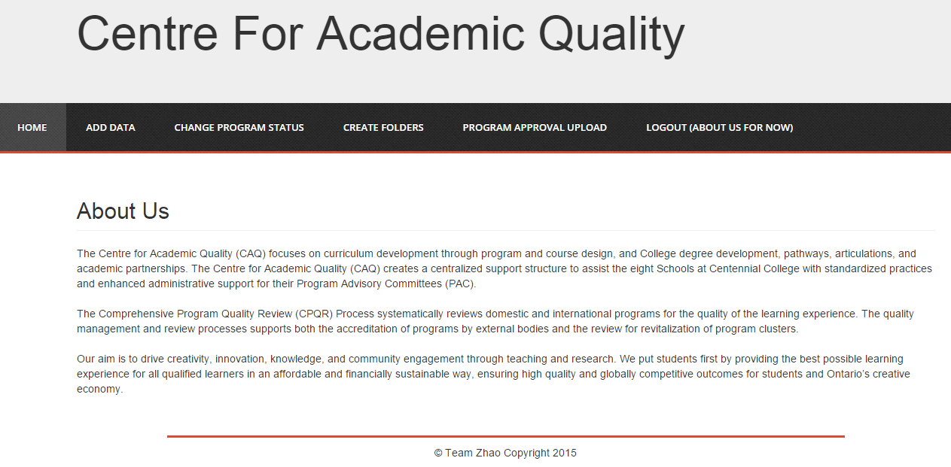

### File Download

When you click download tab, you could download the file by choosing different folder. The web form shows as below:

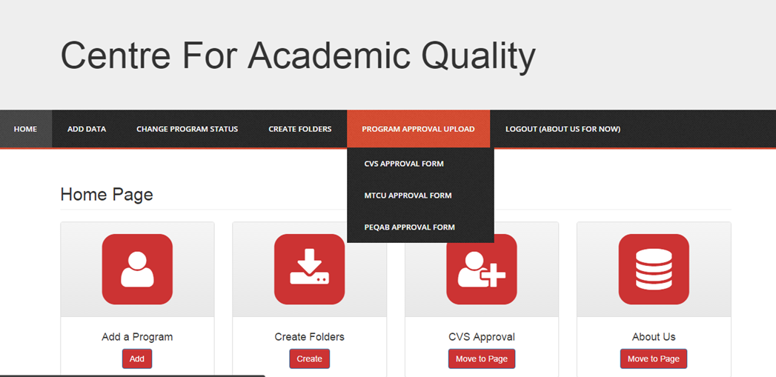

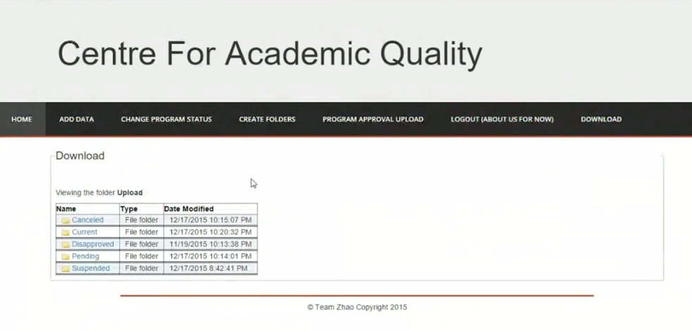

.

# Final Client Acceptance Sign-off

Final client acceptance sign-off meeting has been scheduled on December 18. Therefore it’s not applicable.

# Summary

We are Centennial College students. As a group project for Comp-231 we had the opportunity to work on a real project to develop the web application for one of the department in the College named Centre for Academic Quality (CAQ). The main aspect of the project undertaken was to reduce the heavy load of paperwork and to automate the administrative work process.

# Team Information

|  |  |  |  |  |  |
| --- | --- | --- | --- | --- | --- |
| Surname | Given name(s) | Student ID | Team Role | Gmail | Centennial email |
| Zhao | Chenyu | 300789603 | Developer | lachia.zhao@gmail.com | czhao25@my.centennialcollege.ca |
| Chowdhury | Farhanna | 300812011 | Developer | farhana199312@gmail.com | fchowdh3@my.centennialcollege.ca |
| Cai | Zhaoning | 300817368 | Developer | caizhaoning@gmail.com | zcai9@my.centennialcollege.ca |